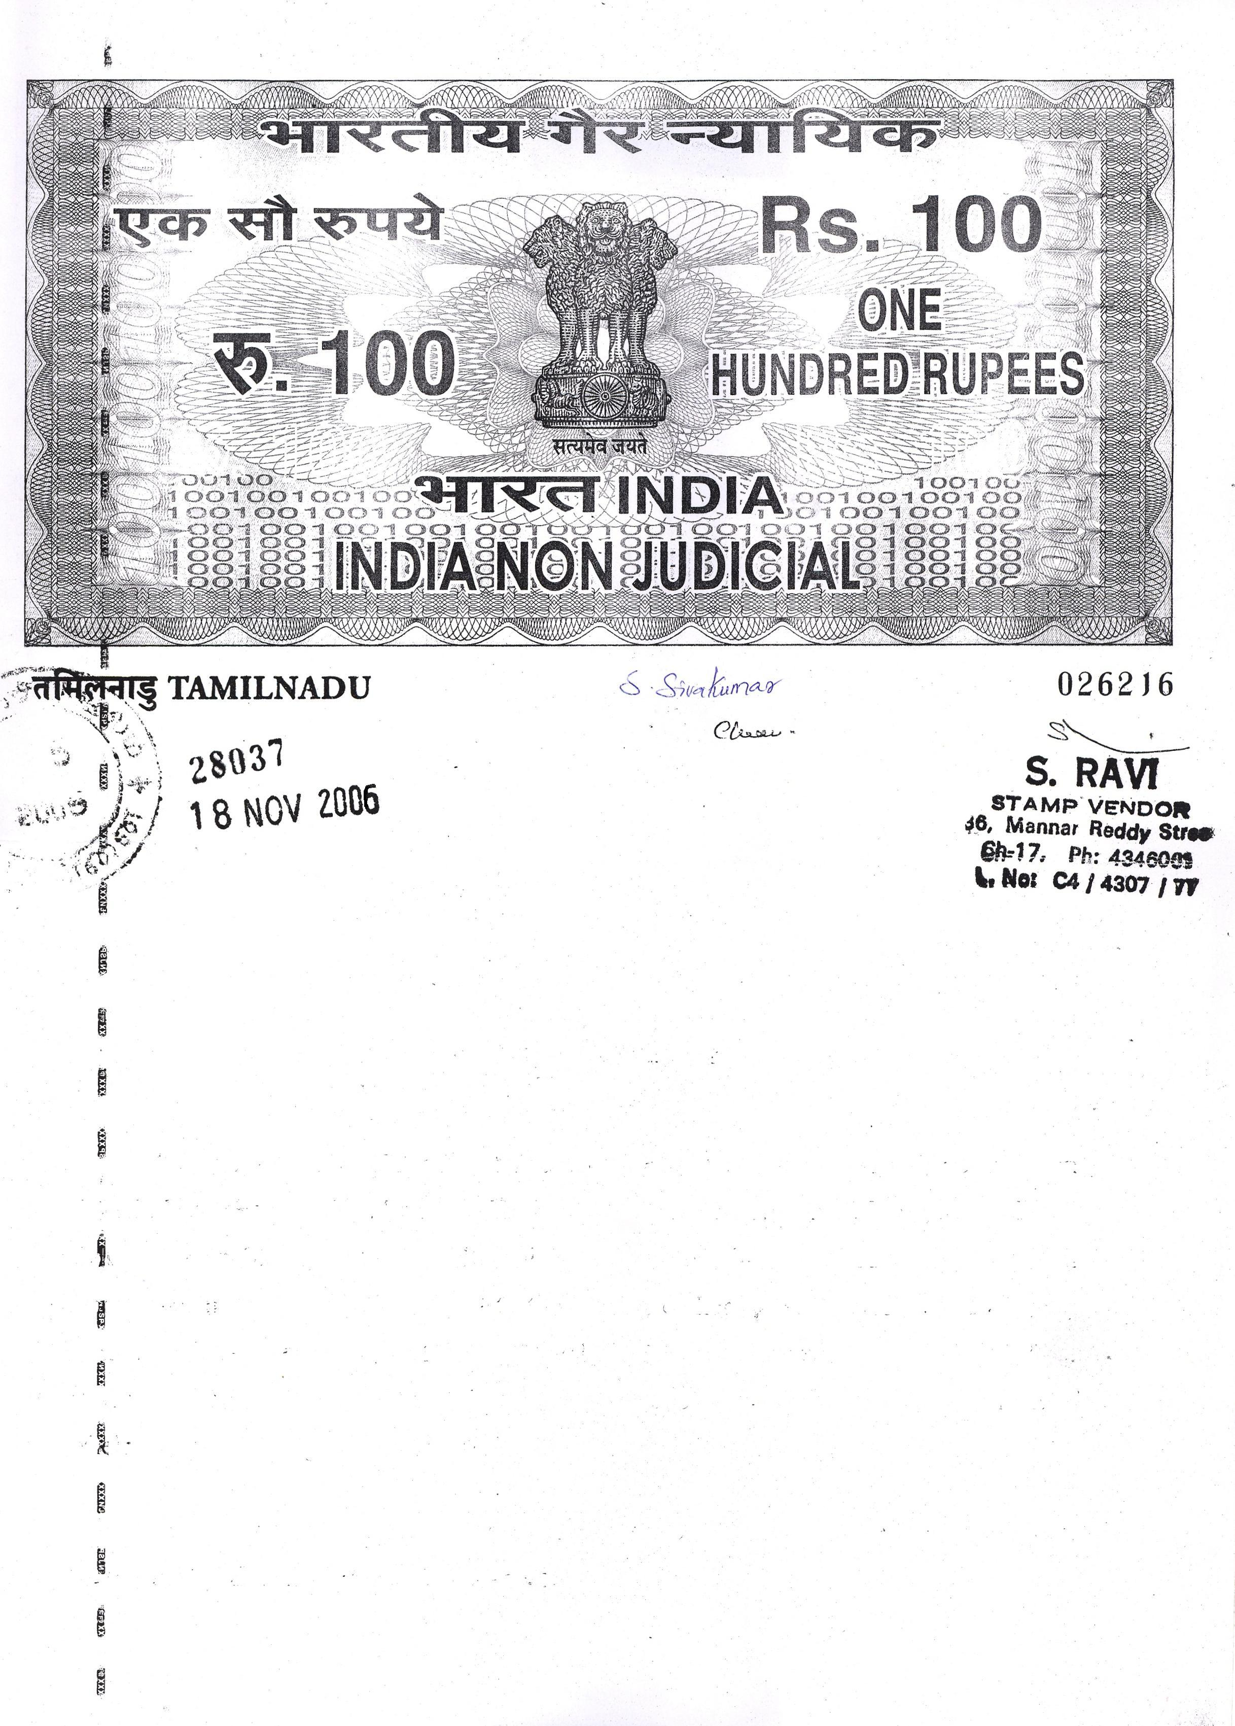

D 5188765

RENTAL AGREEMENT

THIS RENTAL AGREEMENT EXECUTED AT MADRAS on this 9th day of March 2017.

MS. TULASI aged 56 years residing at plot 25, Muthu Nagar, Koluthuvanchery, Chennai – 600122. Herein after called the LESSOR (Whatever the context so admits shall mean and include his hers legal representatives, executors, administrator and assigns its successors in office and assigns of the ONE PART.)

MS.MAYURI D/o MR. SUBRAMANYAM aged 59 years residing at plot 25, Muthu Nagar, Koluthuvanchery, Chennai – 600122. Working at Prodapt as Team Lead herein after called as LESSEE (Which, wherever the context so admits shall mean and include its successors in office and assigns of the OTHER PART.)

- Page 2 -

NOW THIS DEED OF LEASE WITNESSTH as follows:-

- The LESSOR hereby agree to rent out the house at second floor measuring 750 sqft. Situated at plot 25, Muthu Nagar, Koluthuvanchery, Chennai – 600122 on a monthly rent of Rs.8,000/- (Fourteen Thousand ) + Rs.500/-(Five Hundered) as maintenance charges payable according to English calendar months.

- The period of lease shall commence from March 1, 2017. The period of lease till 11 months and may further be extended by mutual consent.

- The LEESEE has paid an amount of Rs 30,000/-(Rupees thirty thousand) to the LEASSOR towards the rental advance.

- The LESSEE shall pay the monthly rent of Rs.8,000/- (Eight Thousand ) + Rs.500/-(Hundered) as maintenance charges to the LESSOR on or before 5th day of every succeeding English calendar month.

- The LESSEE shall keep the rented portion in good and tenantable condition. If the LESSEE causes any damages or breakages, it shall be repaired or replaced by the LESSEE to its original condition, failing which the LESSOR shall be at liberty to deduct the cost of repairing.

- The LESSEE shall not sublet or underlet the above said portion and the LESSEE shall use the above property only for residential purpose.

- The LESSEE shall not make any structural alterations or additions to the said portion.

- The LESSEE shall pay the electricity consumption charges of his portion of house directly to TNEB (TamilNadu Electricity Board).

- In case of default in payment of monthly rent by the LESSEE by two months consecutively, the LESSOR shall be entitled to terminate the tenancy of said portion and shall be entitled to re-take the possession of the above portion.

- The tenancy can also be terminated by LESSOR for LESSEE’s breach of any of the conditions of this rental agreement.

- If the LESSEE desires to vacate the said portion at any time before the expiry of the said period of eleven months of lease, they shall give two months clear notice for the termination of this agreement and in case no notice is given and if suddenly offers to vacate, then the LESSEE shall have to pay two months rent for the notice period to the LESSOR. Similarly if the LESSOR needs the rented portion for his personal use and occupation, then in that case LESSOR shall give two months clear notice.

- The LESSOR shall pay all the taxes and other statutory charges payable for the rented property to the Government or other local body.

- Any dispute arising between the LESSOR and LESSEE will be subject to the jurisdiction of MADRAS Courts only.

- Page 3 -

IN WITNESS WHERE OF THE LESSOR AND THE LESSEE have set their respective hands to this deed of lease on the day, month and year first above written in the presence of

WITNESSES:

1. LESSOR

2. LESSEE

